**Cereal Killer 02**

***Reverse***

**Challenge:**

luciafer can be a bit of trouble sometimes, but she can put away the sugary monster cereals with the best of them! She has a favorite, too, and it is based on her favorite monster. See if you can figure it out! Select the binary for your preferred platform.

Attached - Windows and Linux binaries

**Approach:**

We run the program and its another guess the cereal question.

We decompile the functions using ghidra and see this:

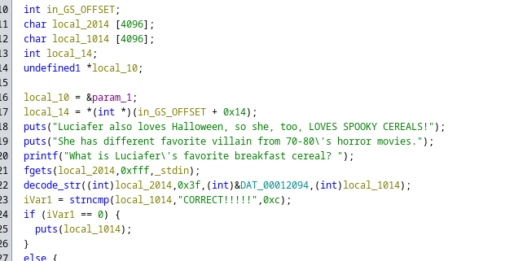

We see this function named decode_str that grabs my interest, and navigate to that function:

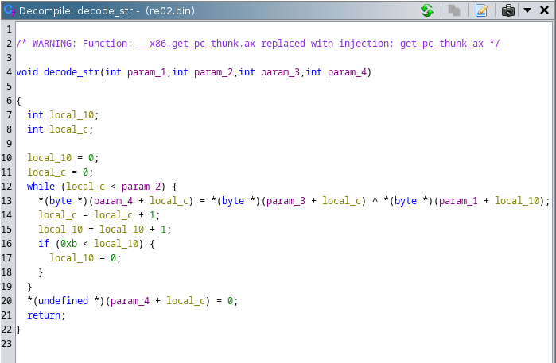

Now this is easy, we just decode this loop to see what operation it performs and solve the flag

**Flag: flag{GramPa-KRAMpus-Is-Comin-For-Da-Bad-Kids!!!}**

Congrats!!

Happy Hacking!